Geographical Location of 33 Houses (LOT #1; LOT #2; LOT #3)
LOT 3
LOT 1
LOT 2

LOT #1-13 Houses
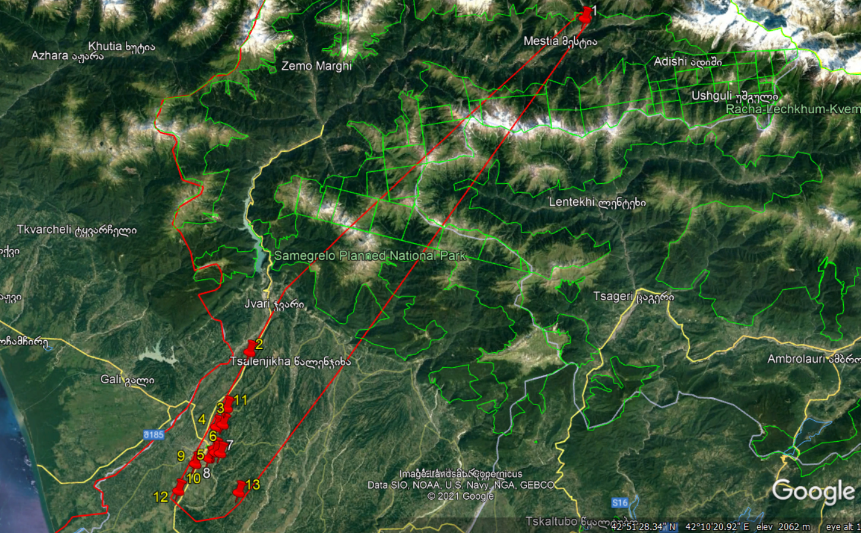

LOT #2-12 Houses
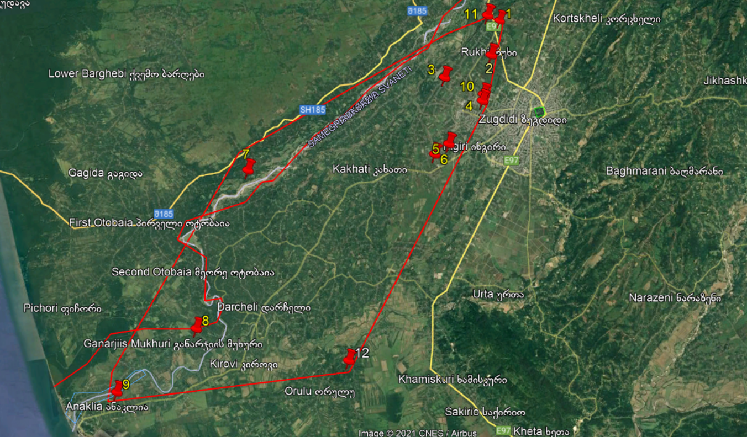

LOT #3-8 Houses

